As per Professor Gridiron, we can use Postgres instead of SQL Server. I went through the “Pubs” database SQL and extracted the CREATE TABLE and INSERT statements and converted them to Postgres SQL.
Here is evidence that the tables are built (left side) and row counts of the key tables.
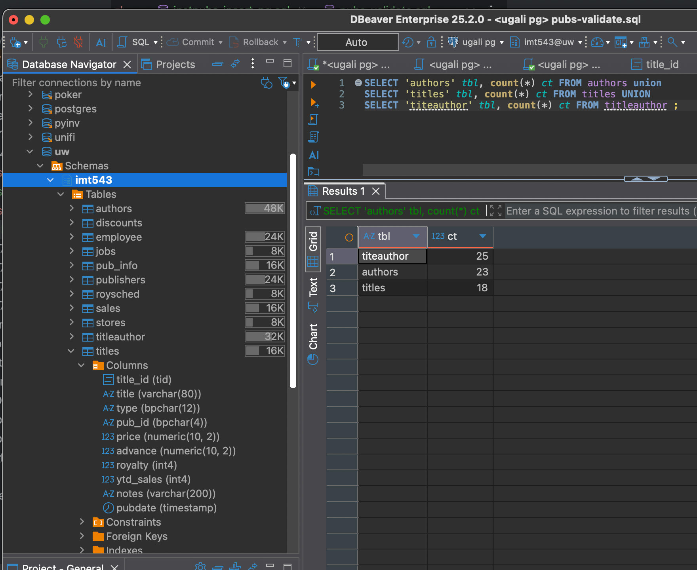
Attached are my SQL files converted.

